**How to import/create a Python’s third-party library on Databricks?**

1. I would assume that you have create a cluster “testing”:

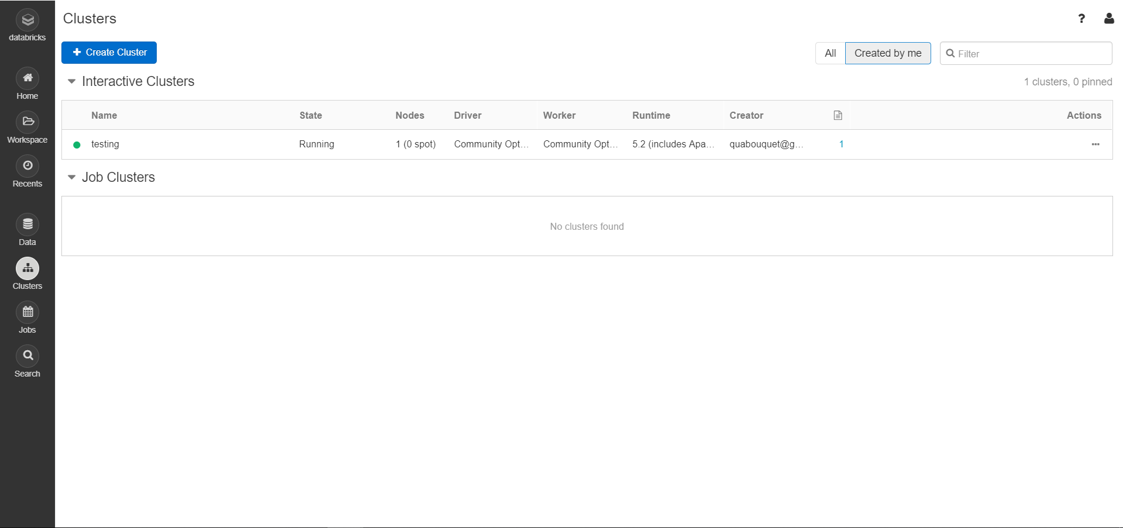

2. Consider that we want to use a library called “wordcloud”. But there’s an ImportError:

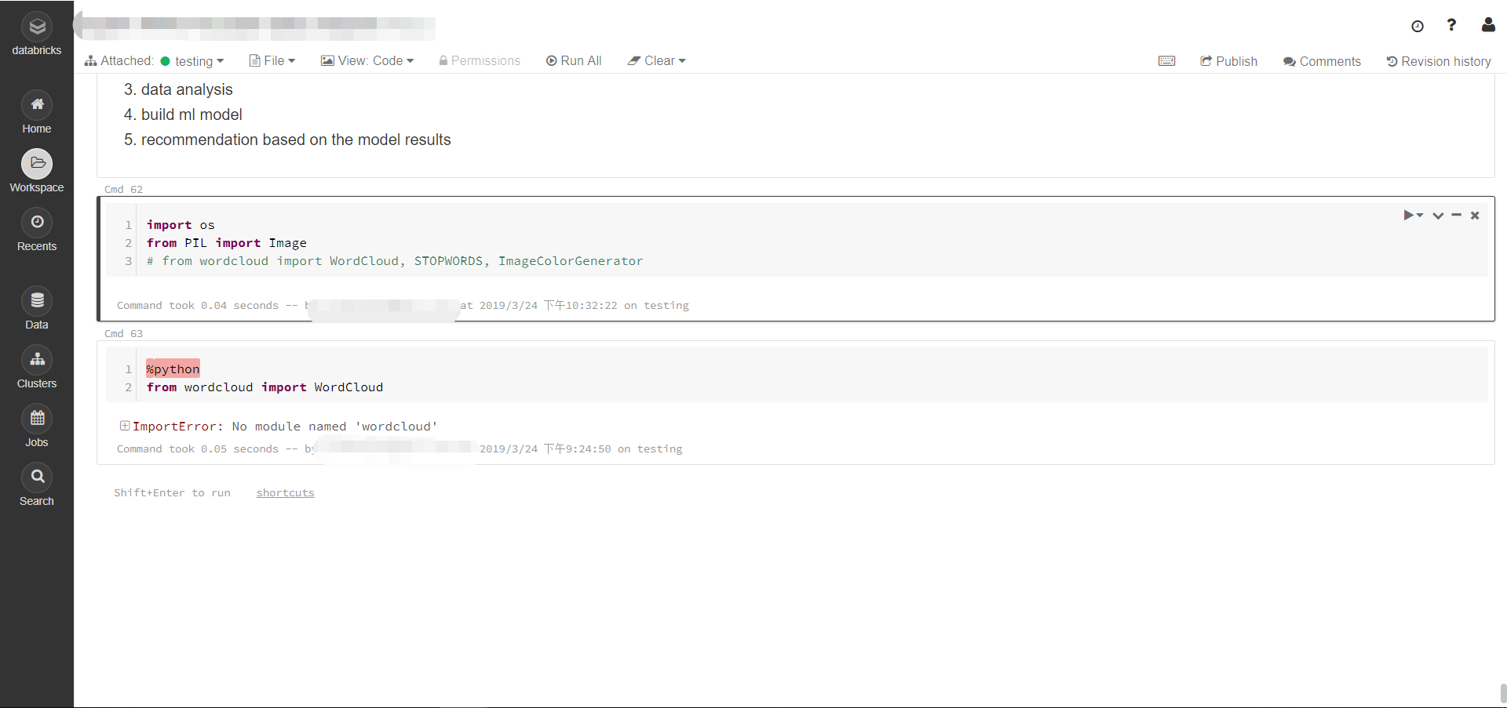

3. To solve this, we click “Workspace” → “drop down arrow” → “Create” → “Library”

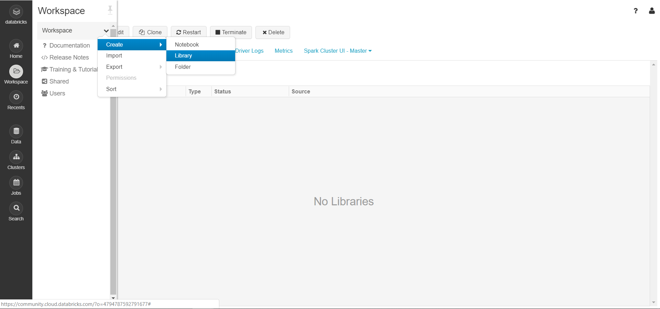

4. Under “Create Library” window, we click: “PyPI” → type the library name you want to install in the “Package” line. Then click “Create”.

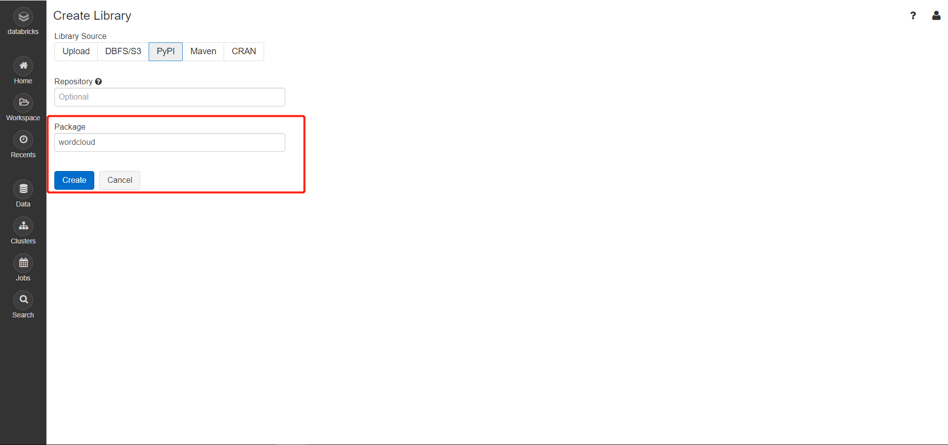

5. Couple seconds later, your library will be installed successfully:

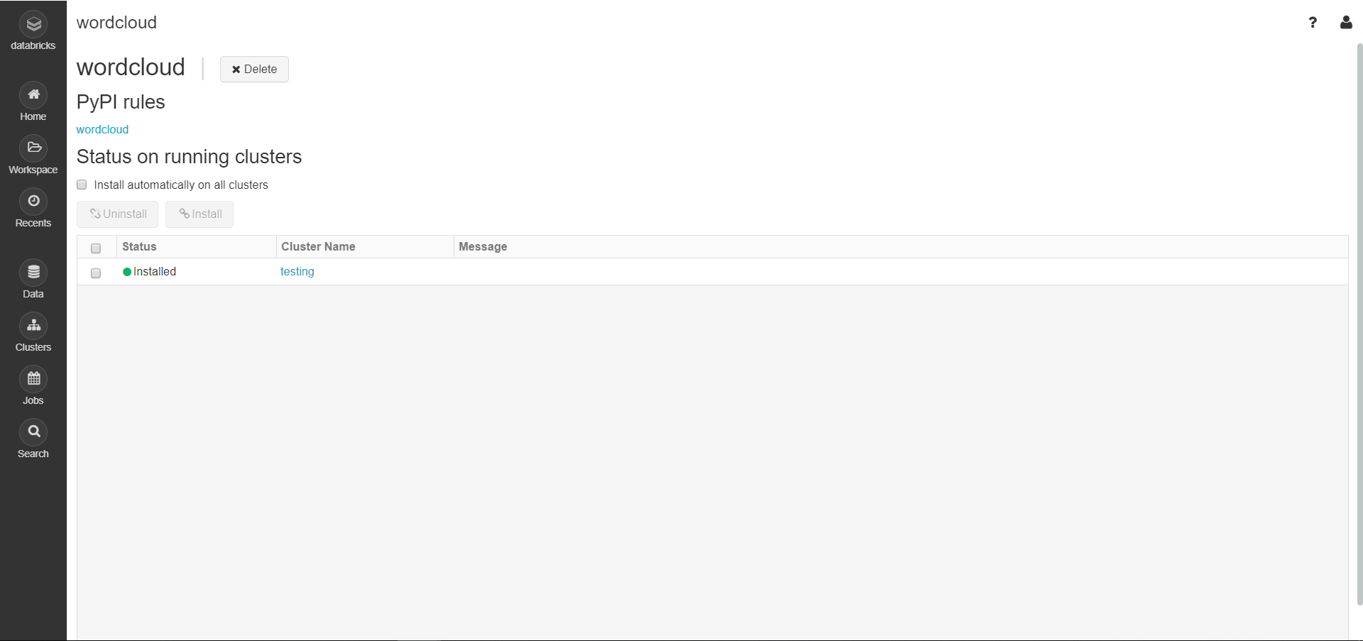

6. Finally, we go back to the Notebook and re-run the command:

